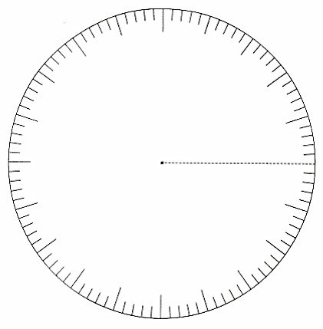

|  |
| --- |
| **TEAM TOTALS** |

**FIND THE TEAM TOTAL**

|  |  |  |  |  |  |  |
| --- | --- | --- | --- | --- | --- | --- |
|  | **FRACTION OR MIXED NUMBER** |  | **CONVERTED TO AN IMPROPER FRACTION** |  | **WITH A COMMON DENOM-INATOR** | |
| **KILLS & ACES** |  | = |  | = | ____  36 | |
| **ASSISTS & DIGS** |  | = |  | = | ____  36 | |
| **BLOCKS** |  | = |  | = | ____  36 | |
| ADDITION WORK HERE:  SUBTOTAL OF  POSITIVE POINTS | | | | ____  36 | | |
| **ERRORS** |  | = |  | = | | ____  36 |
| SUBTRACTION WORK HERE:  TOTAL | | | | ____  36 | | |

|  |  |  |  |  |  |
| --- | --- | --- | --- | --- | --- |
| **THE NUMBER OF KILLS** | | | | | |
|  |  |  |  |  |  |
|  |  |  |  |  |  |

|  |
| --- |
| **CREATE A CIRCLE GRAPH ON THE KILLS DATA FROM THIS PARTIULAR GAME:** |

- - - - - - - - - - - - - - - - - - - - - - - - - - - - - - - - - - - - - - - - - - - - - - - - - - - - - - - - - - - - - - - - - - - - - - - - - - - - - - - - - - - - - - -

|  |
| --- |
| **ROUND**  **TO THE**  **NEAREST HUNDREDTH** |

|  |
| --- |
| **REDUCE**  **FRACTION**  **TO SIMPLEST**  **FORM** |

|  |
| --- |
| **CONVERT**  **FRACTION**  **INTO A**  **DECIMAL** |

|  |
| --- |
| **TEAM**  Frac Total: ______  DecTotal: _______ |

|  |
| --- |
| **REDUCE**  **FRACTION**  **TO SIMPLEST**  **FORM** |

|  |
| --- |
| **ROUND**  **TO THE**  **NEAREST HUNDREDTH** |

|  |
| --- |
| **CONVERT**  **FRACTION**  **INTO A**  **DECIMAL** |

|  |
| --- |
| **ERRORS**  **(E, SE, and RE)** |

|  |  |  |  |  |  |
| --- | --- | --- | --- | --- | --- |
|  | **E** |  | **SE** |  | **RE** |
|  |  | + |  | + |  |
|  |  | + |  | + |  |
|  |  | + |  | + |  |
|  |  | + |  | + |  |
|  |  | + |  | + |  |
|  |  |  |  |  |  |
| **E, SE, and RE**  **Total:** |  | **X** | **- 1**  **18** | | |

|  |
| --- |
| **E, SE and RE’s**  **Frac: _____**  **Dec: _____** |