THE NUMBER SYSTEM
STUDY GUIDE, Page 1

- The length of the shaded rectangle represents 2 1/2 units.
Part A: Drag enough 1/4 units into the empty rectangle to model 2 1/2 divided by 1/4
Part B: Drag a number into the box to show the quotient of 2 1/2 ÷ 1/4.

1/4  0  1  2  3  4  5  6  7  8  9 | Part A:
Part B:

2 1/2 ÷ 1/4 =

- What fraction makes this equation true?

2 ÷ ___ = 2

3 3
Drag a number into each box to create a fraction that will make the equation true?
THE NUMBER SYSTEM STUDY GUIDE, Page 2

- What number makes this equation true?

2 ÷ ___ = 14
3 7 21

Drag a number to the box to create a fraction that will make this equation true.

4. Which expression is equivalent to 1/4 ÷ 1/8 ?

a) 1/4 • 1/8 c) 4/1 • 8/1

b) 1/4 • 8/1 d) 4/1 • 1/8

5. The equation has an unknown number.

___ ÷ 5 = 4
3 6 5

Enter a number that makes this equation true.

- Enter the quotient of 2/3 and 3/4 in fraction form.

THE NUMBER SYSTEM STUDY GUIDE, Page 3

- The Equation shown has an unknown number?

÷ 2 = 3
3 4

Enter a fraction that makes this equation true.

- Enter the quotient of 2 2/3 and 3/4 in fraction form.

- A recipe requires ¾ cup of nuts for 1 batch of muffins.

Enter the number of batches of muffins that can be made using 7 1/2 cups of nuts.

- Divide. 16,536 ÷ 24
Enter the exact quotient.

THE NUMBER SYSTEM STUDY GUIDE, Page 4

- Divide. 12. Add.
Enter the exact quotient. Enter the exact sum.

35, 702 ÷ 25 34.381 + 8.2

- Subtract. 14. Multiply
Enter the exact difference. Enter the exact product.
48.235 – 29.67 8.296 • 0.8

- Use the fact that 12 • 218 = 2616
Enter the exact product of 1.2 • 2.18.

THE NUMBER SYSTEM STUDY GUIDE, Page 5

16. Divide. 0.912 ÷ 0.24
Enter the exact quotient.

- Consider the equation showing the distributive property.

24 + 30 = 6(4 + )

Enter the unknown value that would make the equation true.

18. Enter the greatest common factor of 24 and 36.

19. Enter the least common multiple of 6 and 8.

THE NUMBER SYSTEM STUDY GUIDE, Page 6

20. A Fahrenheit thermometer shows that the temperature is 15 degrees below zero.

Enter the integer that represents the temperature in degrees Fahrenheit.

21. -3°C > -7°C, where as C represents Celsius. Write a statement about the above temperatures.

__________________________________________
__________________________________________
__________________________________________

22. Roman civilization began in 509 B.C. and ended in 476 A.D. How long did the Roman civilization last?

23. A submarine was situated 450 feet below sea level. If it descends 300 feet, what is its new position in feet?

THE NUMBER SYSTEM STUDY GUIDE, Page 7

24. In the Sahara Desert one day it was 136°F, and in the Gobi Desert a temperature of -50°F was recorded. What is the difference between these two temperatures?

25. What is the absolute value of the integer -18?

a) -18 c) 18

b) 1 and 8 d) 0

26. Select all ordered pairs that are located in the second quadrant of the coordinate grid.

a) (-3, 4) c) (-5, 4)

b) (3, -8) d) (-5, -8)

27. Identify the points on the number line below:

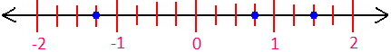
THE NUMBER SYSTEM STUDY GUIDE, Page 8

28. Identify the points on the number line below from greatest to least:
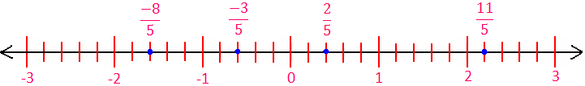

Which number on the number line has the greatest absolute value?

29. Identify the ordered pairs in the coordinate grid.

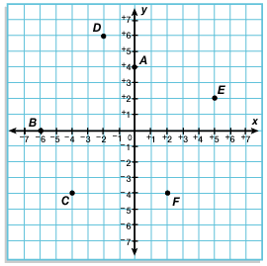

THE NUMBER SYSTEM STUDY GUIDE, Page 9

30. In what quadrant would we find the ordered pair, (-4, 4)?

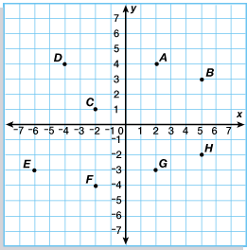

a) quadrant I c) quadrant III

b) quadrant II d) quadrant IV

31. Place the values below on the number line in the correct positions:

1/2, -4, -2 3/4, 3, 1 1/4

THE NUMBER SYSTEM STUDY GUIDE, Page 10

32. Mom mixed 2 1/2 pounds of apples, 1 1/8 pounds of grapes and 1 1/4 pounds of pears for a salad. After setting aside 1 1/2 pounds of salad for today, she divided the rest of the salad equally into 3 containers. What is the weight of the salad in one container?

33. Jill bought items costing $13.45, $1.99, $6.59, and $12.98. She used a coupon worth 20% off. The tax on all the items was .09¢. If Jill had $50.00 when she went into the store, how much did she have when she left? And she gives the remaining money to 2 charities. How much money does she give to each charity?

