GEOMETRY
STUDY GUIDE, Page 1
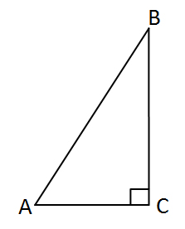
- A triangular-shaped garden is shown below:

Garden m
5 m

8 m m

Enter the area of the garden in square meters.

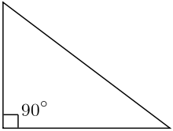
- Consider this figure:

7 in

12 in

Enter the area of the right triangle in square inches

GEOMETRY STUDY GUIDE, Page 2

- Consider the map of the Bermuda Triangle located between Florida, Bermuda, and Puerto Rico:
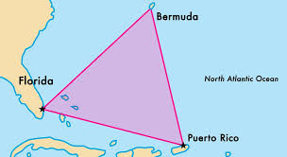

954 miles
1000 miles

- - - - - - - - - - - - - - - - - - - - - -

What is the area of the Bermuda Triangle?

- Consider the Triangle Club’s logo below:

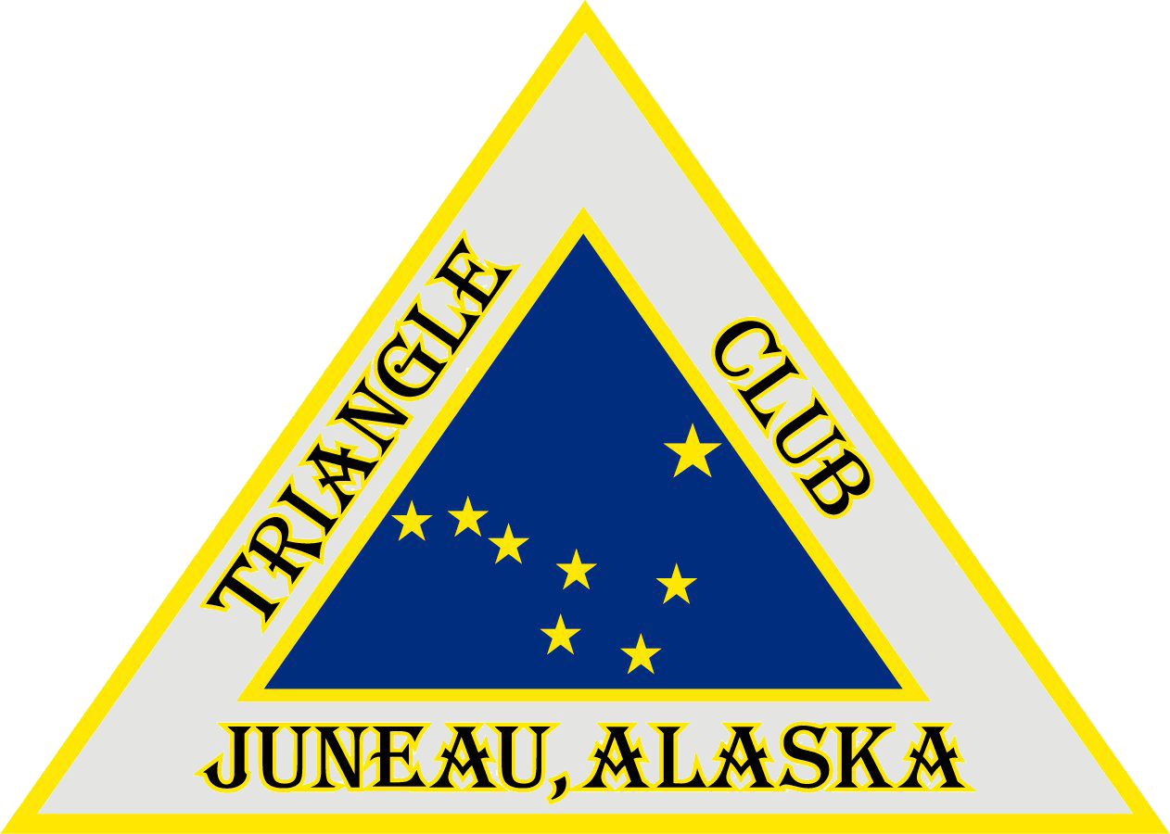
30.25 cm

- - - - - - - - - - - - - - - - - - - - - - - - - - - - - - - - -

45.5 cm

What is the area of the entire logo?
GEOMETRY STUDY GUIDE, Page 3

- Consider the figure of a kite below:
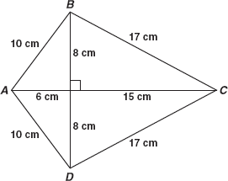

Enter the total area of kite ABCD in square centimeters.

- A skate company is using this design on the back of their t-shirts, and they want the size of the triangle to be no larger than 36 centimeters in area.

9 cm
Area =
36 cm²
- - - - - - - - - - - - - - - - - - - - - - - - -

What is the height of the design?
GEOMETRY STUDY GUIDE, Page 4

- Decompose this special quadrilateral below and find the area of the trapezoid.
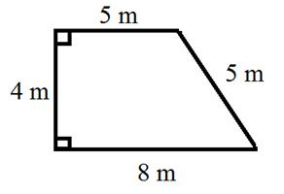

- Decompose this special quadrilateral below into two triangles and find the area.
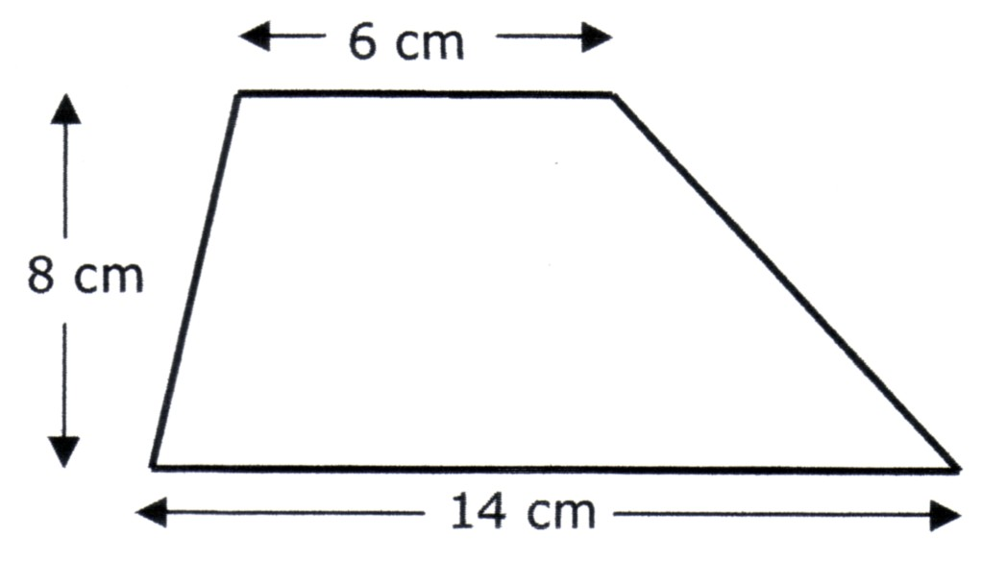

9. Consider the tabletop below:

What is the area of the tabletop in square centimeters?

GEOMETRY STUDY GUIDE, Page 5

10. Consider the figure below:
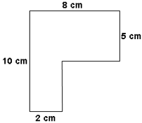

This irregular shape design is made by joining two rectangles together. Enter the total area of the design in square centimeters.

11. Consider the polygon below:
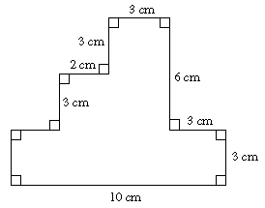

What is the area in square centimeters?

GEOMETRY STUDY GUIDE, Page 6

- Consider the dimensions in the figure below:
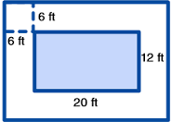

What is the total area of the design in square feet? And what is the area in square feet of just the white border? Explain the procedures you followed in finding the area.
____________________________________________________________________________________________________________________________________________________________________________________________

13. Consider the figure below:

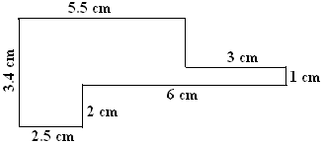

What is the area in square centimeters?

GEOMETRY STUDY GUIDE, Page 7

- What are the two formulas to find the volume of any given 3-dimensional object or right rectangular prism?

____________________ and ____________________

15. Consider the 3-dimensional figure below:

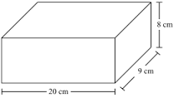

Enter the volume of the right rectangular prism in cubic inches.

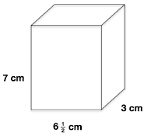
16. Consider the container to
the right:

Enter the volume of the container
in cubic centimeters.

GEOMETRY STUDY GUIDE, Page 8

17. In the box, pictured below, we will be shipping 6 in. x 6 in. boxes containing Christmas ornaments.
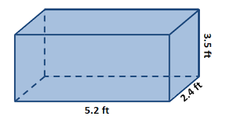

Part A: What is the volume in cubic feet?

Part B: How many ornaments will we be able to ship in each box?

18. Consider this shipping container from the local post office:
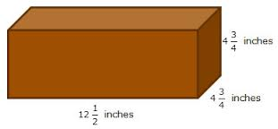

How many 2 in³ will I be able to ship in this box?

GEOMETRY STUDY GUIDE, Page 9

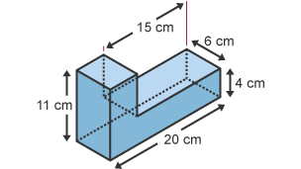
- This solid, pictured below, was created by joining two right rectangular prisms:

Enter the volume of the solid in cubic centimeters.

- Susan is painting the outside of a square pyramid. The net for the pyramid is shown below:
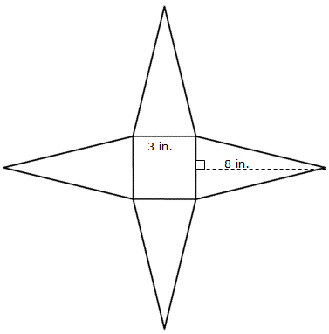

Enter the total surface area of the pyramid that Susan will paint in square inches.

GEOMETRY STUDY GUIDE, Page 10

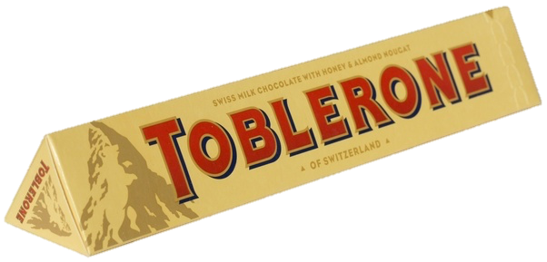
21. Consider the triangular prism below:

- - - - - - - - - - - - - - -
17.2 cm
3 cm

3 cm

Enter the total surface area of the triangular prism in square centimeters.

22. What is the surface area of the rectangular prism below:
12 in.
3½ in.

14 in.

Enter the surface area in square inches.

GEOMETRY STUDY GUIDE, Page 11
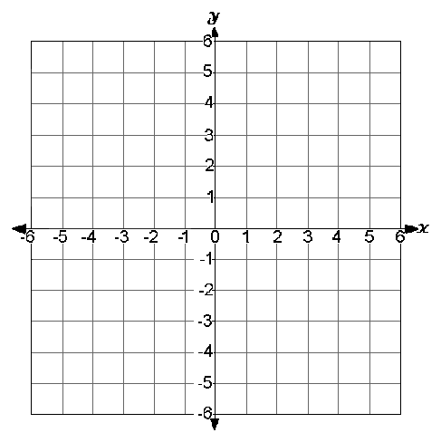
23. Consider these ordered pairs.
Use the “Add Point” and “Connect Line” tools to connect the three points to form triangle ABC.

Point A: (3,2)
Point B: (⁻3,2)
Point C: (3,⁻2)

- A triangle has these three
coordinates:

Point A: (⁻5,2) Enter the length
Point B: (-5,6) of side AC.
Point C: (7,2)

- On the map Leland St. is located at (-4,5), Alma Market is located at (5,1), and Busy Bee is at (4,⁻5). Each square unit in the grid represents 1 kilometer.

Enter the distance from the
Leland St. to Busy Bee in
kilometers.

GEOMETRY STUDY GUIDE, Page 12

26. The Company of Miller Mills currently sells delicious pumpernickel crackers in a box that measures 10 inches x 12 inches x 2 inches, which costs .04¢ to produce per box. Miller Mills and Co. does not want to cheat its customers of any product, but it would like to save money in the production of it’s boxes, and bring the cost down to .03¢

Part A: Find the volume and surface area of the current pumpernickel cracker box.

Part B: Create a new box with less cardboard, but keeps the same volume of crackers in each box thus saving Miller Mills and Co. money.

Part C: If Miller Mills and Co. uses the new box design, they will produce and sell 240,000 boxes of pumpernickel crackers in the month of March. How much money will they have saved for March? And the rest of the year? Explain.

________________________________________________
________________________________________________
________________________________________________
________________________________________________

