|  |
| --- |
| **ONE-HALF** |

|  |
| --- |
| **EQUIVALENTS: 2 3 4 5 6**  **4, 6, 8, 10, 12, etc.** |

|  |
| --- |
| **1**  **2** |

|  |
| --- |
| **DECIMAL TO**  **PERCENT** |
| **.5 0**    **× 1 0 0**  **5 0 .0 0** |
| **PERCENT: 50%** |

|  |
| --- |
| **FRACTION TO DECIMALS** |
| **1 0.500**  **2 1.000**  **- 1 0**  **000** |
| **DECIMAL: 0.50** |

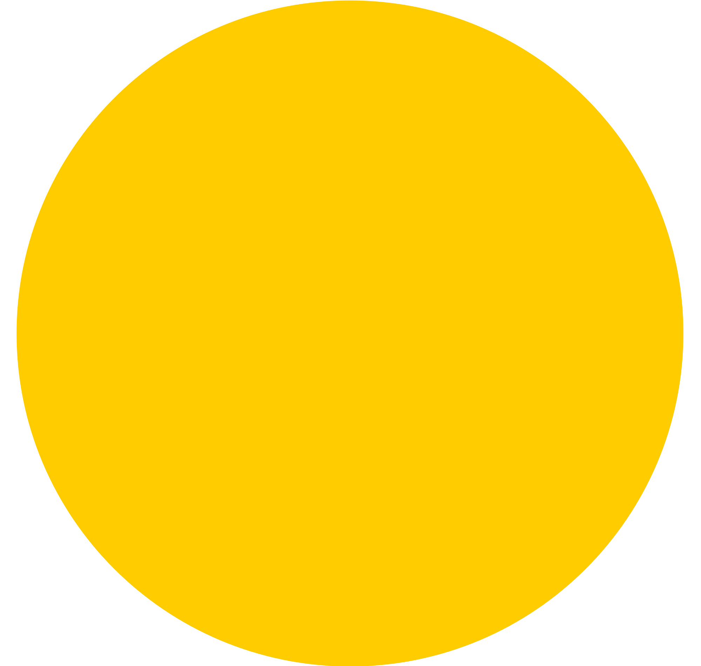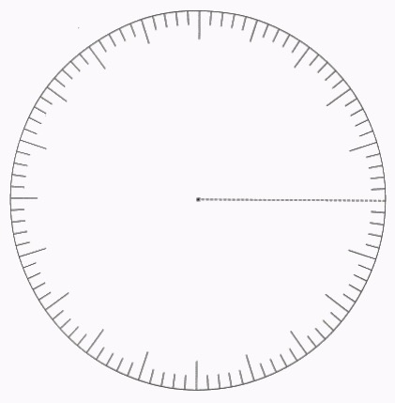

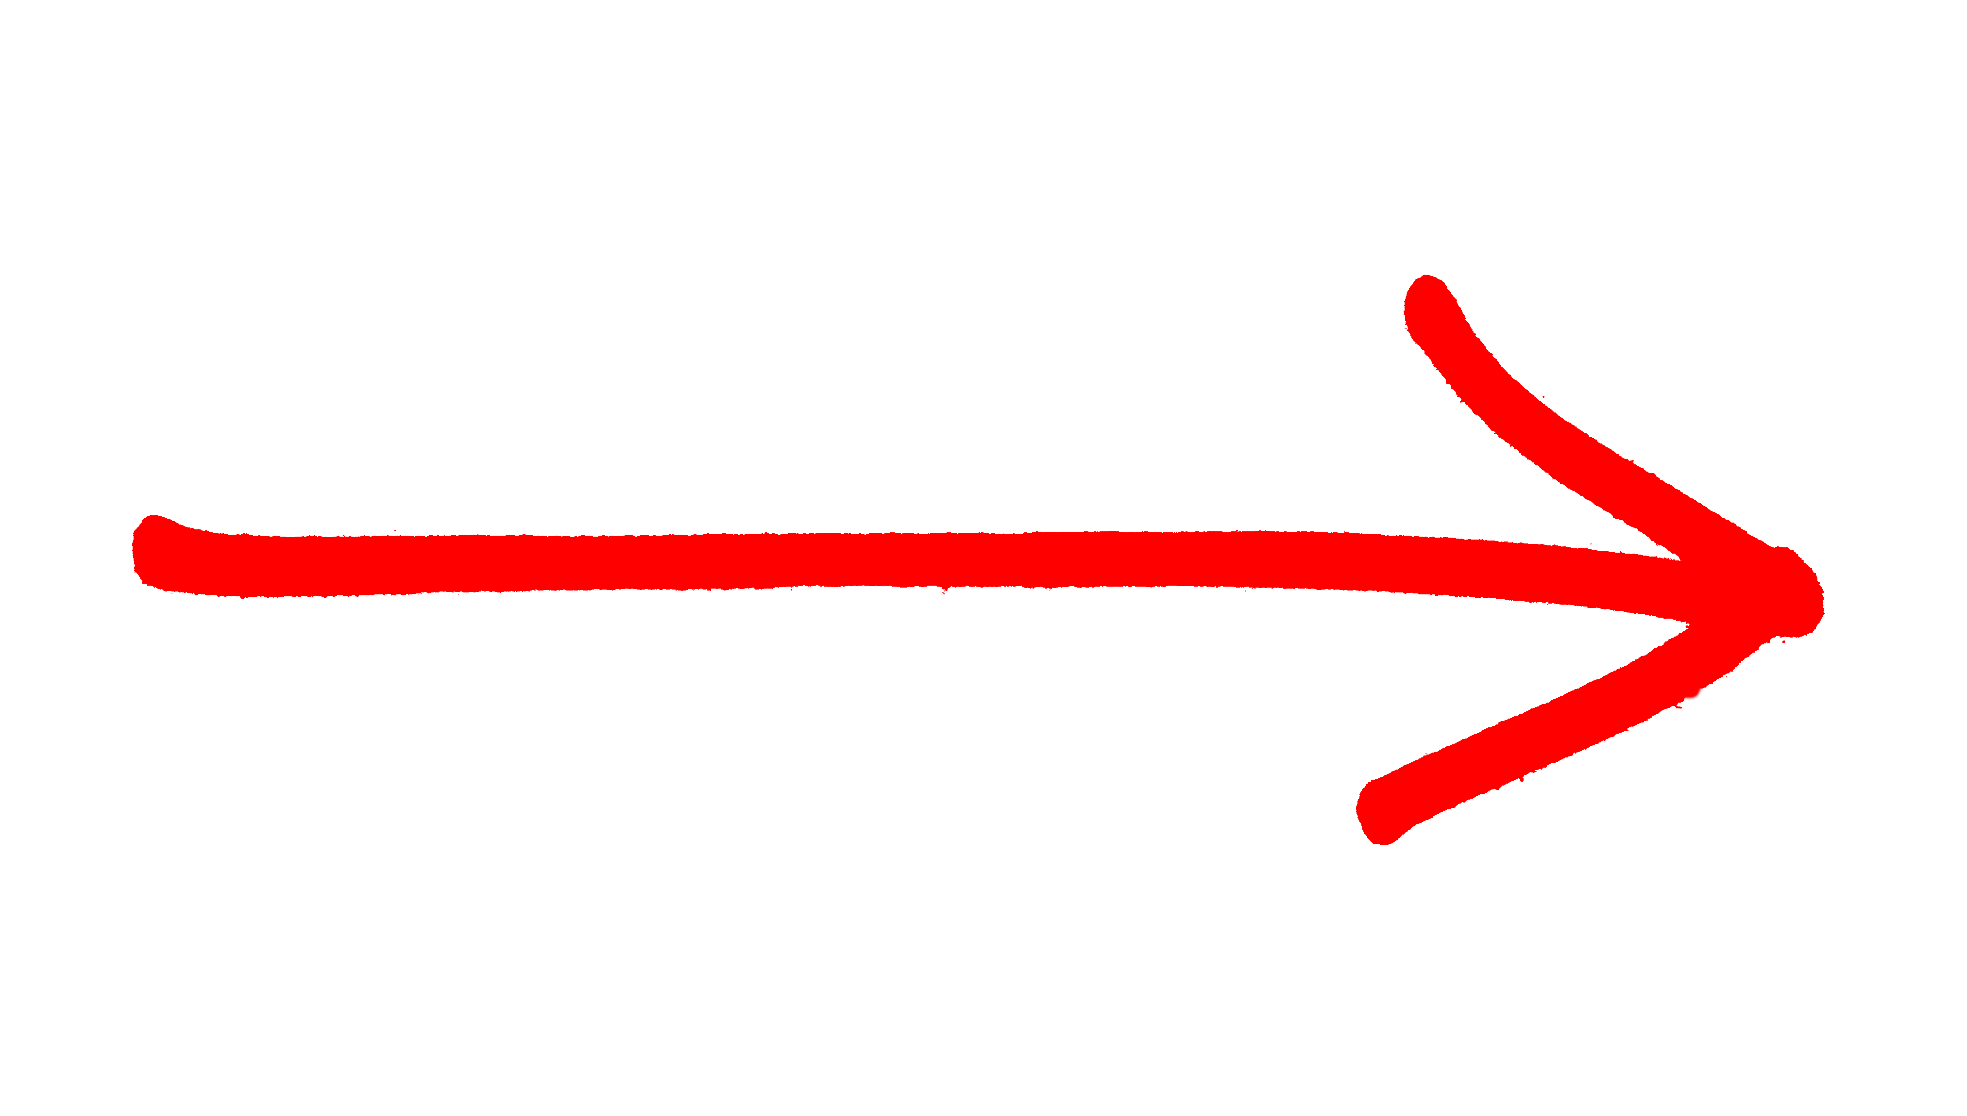

**2**

**spaces**

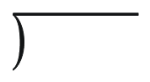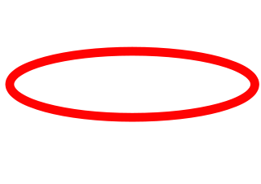



|  |
| --- |
| **MINS.** |
| **30** |

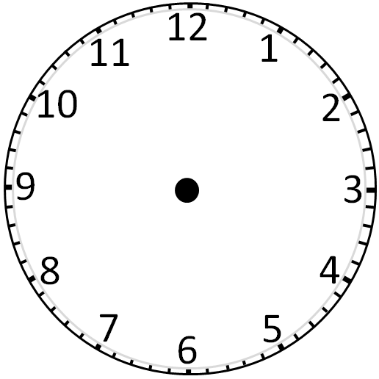

|  |
| --- |
| **CLOCK** |

|  |
| --- |
| **NUMBER LINE** |

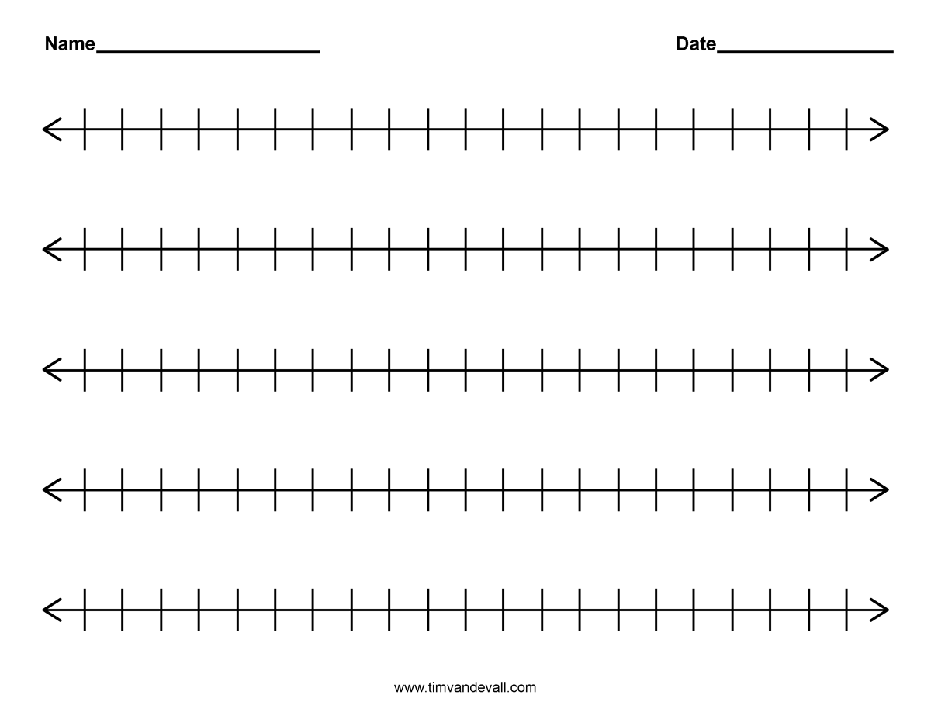

|  |
| --- |
| **MONEY** |
|  |
| **CENTS: .50¢** |

**- 1**

**2**

**1**

**1**

**2**

**-1**

**1**

**1**

**2**

**0**

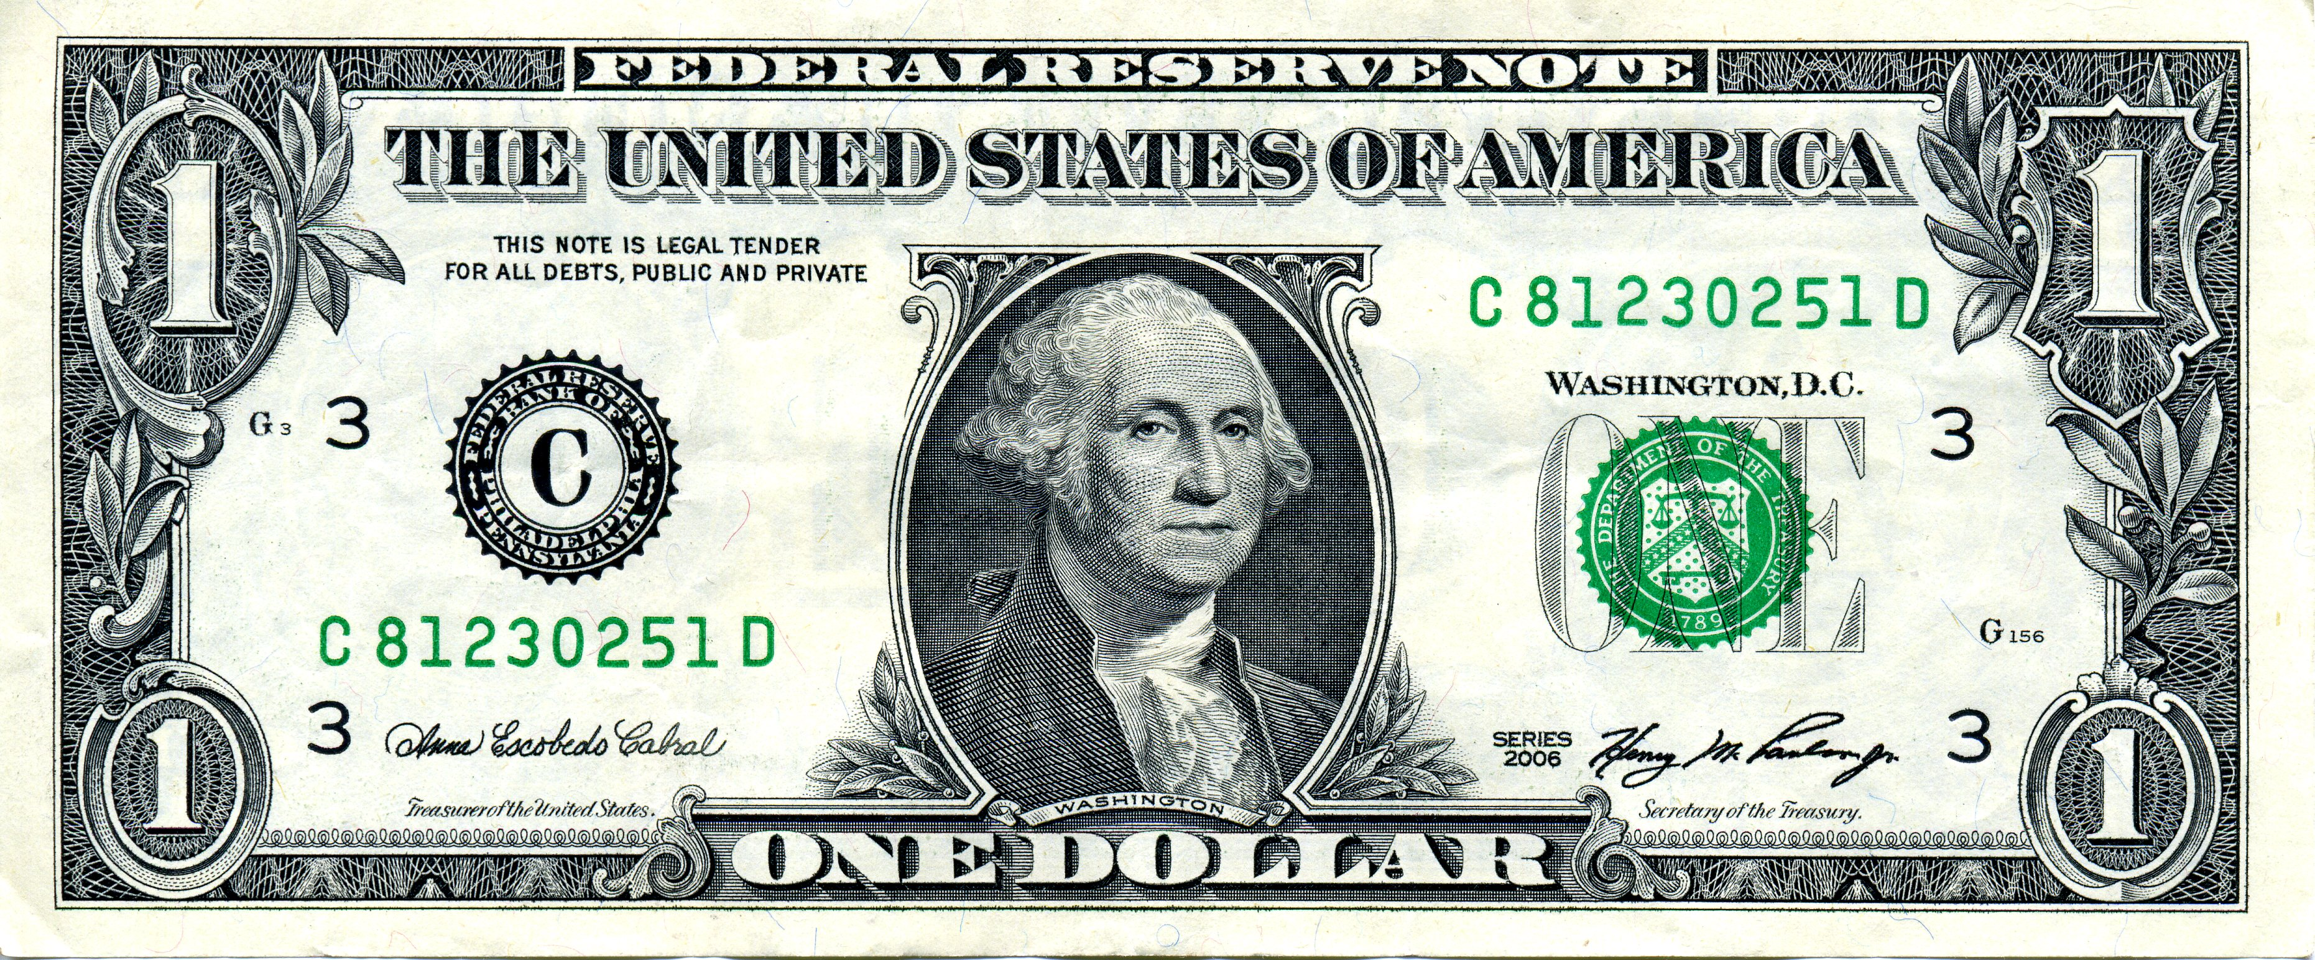

* - - - - - - - - - - - - - - - - - - - - - - - - - - - - - - - - - - - - - - - - - - - - - - - - - - - - - - - - - - - - - - - - - - - - - - - - - - - - - - - - -

|  |
| --- |
| **2**  **2** |

|  |
| --- |
| **EQUIVALENTS: 2 4 6**  **2, 4, 6 etc.** |

|  |
| --- |
| **TWO-HALVES / ONE WHOLE** |



|  |
| --- |
| **FRACTION TO DECIMALS** |
| **2 1. 000**  **2 2.000**  **- 2**  **0 000** |
| **DECIMAL: 1.00** |

|  |
| --- |
| **DECIMAL TO**  **PERCENT** |
| **1 .0 0**    **× 1 0 0**  **1 0 0 .0 0** |
| **PERCENT: 100%** |





**2**

**spaces**



|  |
| --- |
| **MINS.** |
| **60** |







|  |
| --- |
| **CLOCK** |

|  |
| --- |
| **NUMBER LINE** |

|  |
| --- |
| **MONEY** |
|  |
| **CENTS: $1.00** |



**4**

**3**

**2**

**1**

**0**

**- 1**

**-**2

**-**3