Eureka Math: Mod. 1 L. 1
MATH CCSS: 5.NBT.A.1

COMPARE DECIMAL PLACE VALUE

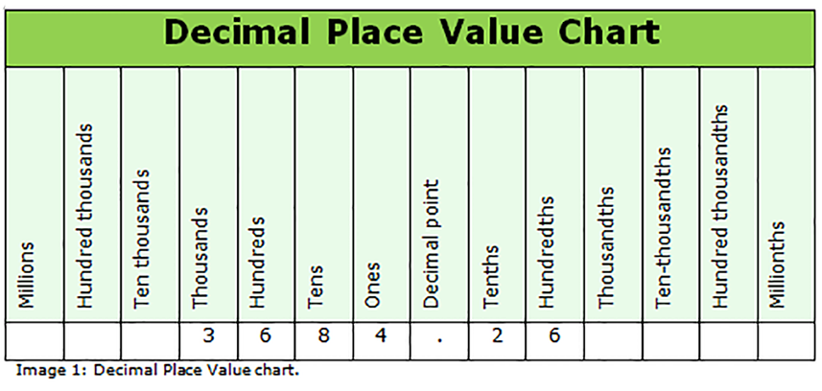
Standard: Recognize that in a multi-digit number, a digit in one place represents 10 times as much as it represents in the place to its right and 1/10 of what it represents in the place to its left.

The standard wants you to recognize that the 6 in the hundreds place is 10 times bigger than the 4 in the tens place, and that the 6 in the hundreds place is 1/10 of what the 3 represents in the thousands place.

EXAMPLE

In which number does the digit 8 have a value that is 1/10 times as great as the digit 8 in the number 2,980.7?
The value of the digit 8 in 2,980.7 is in the tens place, so 1/10 times as great means I am decreasing one place value which would be the ones place, so the 8 in 548 is 1/10 times as great as the 8 in 2,980.7. In other words 8 is 1/10 times as great as 80.

a) 3,023.8
b) 8,659
c) 389.3
d) 548

The value of the digit 5 in 4.59 is 5 tenths, so a number that is ten times greater means the 5 has to be in the one’s place. 5 is 10 times as great as 0.5.

In which number does the digit 5 have a value that is 10 times as great as the digit 5 in the number 4.59?
a) 578
b) 31.757
c) 2,775.9
d) 134.591

ERROR ANALYSIS
a) the 5 is in the hundreds place, b) the 5 is in the tenths place, c) the 5 is in the ones place, and d) the 5 is in the tenths place.

To master this standard, you really need to be familiar with the place value chart, and be able to recreate one at any given point.

BASE TEN

Eureka Math: Mod. 1 L. 1
MATH CCSS: 5.NBT.A.1

VALUE OF A DIGIT

Students need to be able to distinguish the value of a digit within its position in the place value chart.

COMMON MISUNDERSTANDINGS AMONG 5TH GRADERS
Place value can be pretty abstract especially when we are discussing very large numbers in the millions, and especially anything smaller than hundredths. For example consider this common comparison:

Which is greater? .2 or .002

Hopefully most students will understand that .2 is a greater number than .002, but I think that lots of students hear themselves say tenths and thousandths and quickly assume that thousandths is larger, when in reality it is much smaller. Students need to understand that .002 is 100 times smaller than .2.

Compare and order the list of numbers from least to greatest:

.039, .39, 3.9, .390

.039
.39
3.9
.390

.039
.39
3.9
.390

0.039
0.390
3.900
0.390

The numbers from least to greatest are: .039, .39, .390, 3.9

First of all, students need to be familiar with a place value chart, and should be able to recreate one at any opportunity to do so.

Secondly, when comparing two or more numbers, students should stack them in such a way as to preserve the place value. Next step is to fill in empty spaces with zero.
First, I need to preserve place value, so I’ll line up the decimal points.

EXAMPLE

Here I can see that I have 3 wholes, so that’s my greatest number. Now I am going to fill in the missing place values with zero.

The digit 2 in which number represents a
value of 0.002?
ERROR ANALYSIS
The digit 2 is in the thousandths place in the question, and in a) the 2 is also in the thousandths place. In b) the 2 is in the ones place, c) the 2 is in the tenths place, and in d) the 2 is in the ones and tenths place.

a) 8.032
b) 162
c) 0.324
d) 72.230
Now working from left to right, I can clearly see that 3.9 is my greatest number, because the other whole numbers in place value are 0.

The second and fourth numbers are equal at 0.390, which is easy to see once the zero is added. This leaves the number 0.039 as the least because obviously the zero in the tenths place is less than 3.

What value does the 4 represent in the
number 487.009?
ERROR ANALYSIS
The value of 4 in the question is 400 hundred, so the only answer is b) 400. a) is the wrong value, c) is a misread of the decimal point and comma, and d) demonstrates a misunderstanding of place value.

a) 40
b) 400
c) 400,000
d) .400

BASE TEN

MULTIPLY AND DIVIDE BY POWERS OF 10

Eureka Math: Mod. 1 L. 2
MATH CCSS: 5.NBT.A.2

Standard: Students should be able to explain patterns when multiplying or dividing by powers of 10 especially when it involves the movement of the decimal point.

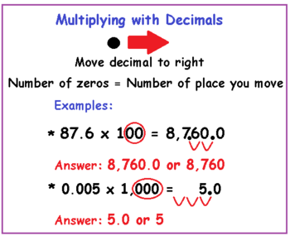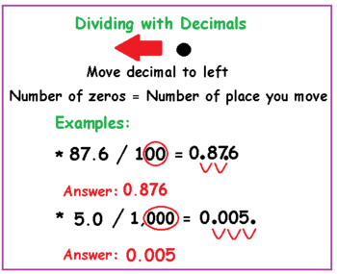

Students should understand that every number has a decimal point whether it is seen or not, and that decimal point moves to the right for multiplication and to the left for division.

Students should be able to explain why they are moving the decimal point one way or another and not just memorizing a little math trick.
In this lesson, students used the place value chart and based on multiplying or dividing by 10, 100, or 1000 use arrows to designate a digits new position in place value.

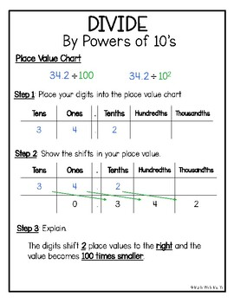
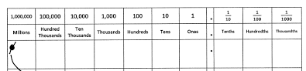
I think it’s
actually easier to
add a 0 or take a 0 depending on the operation.

EXAMPLE

Solve.
a) 36,000 • 10
In this case, 36,000 is placed correctly in the place value chart and because we are multiplying by 10, we are moving one place value to the left to make it 360,000. If we multiplied by 100 we’d move two spaces to the left, and our answer: 3,600,000

b) 36,000 ÷ 10
Likewise, because this is division we’d move one space to the right and our answer would be 3,600. And if we divided by 100 our answer would be 360.

BASE TEN

Eureka Math: Mod. 1 L. 3
MATH CCSS: 5.NBT.A.2

POWERS OF 10 EXPLAINED
by Mathematics-Monsters.com

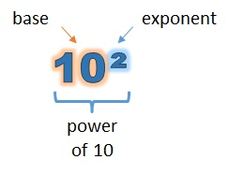
The small 2 written beside the 10 means it is raised to an exponent of 2. This means 10 is multiplied by itself 2 times.

10² = 10 • 10 = 100

10³ = 10 • 10 • 10 = 1,000

10⁴ = 10 • 10 • 10 •10 = 10,000

10⁵ = 10 • 10 •10 • 10 • 10 = 100,000

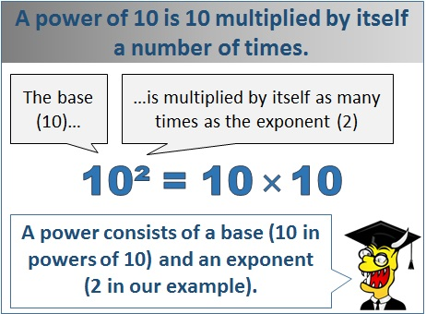

Notice how 10 to the power of 3 is 1,000. There are 3 zeroes after the 1. Check out that pattern.

If we understand that all numbers have a decimal point whether it is seen or not, then we can also divide by powers of 10.

EXAMPLE

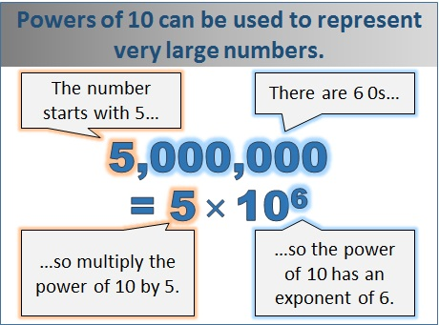

Write the following in standard form
(e.g. 5 • 10³ = 5,000)

MULTIPLICATION

72 • 10⁴ = 72 • 10,000 = 720,000

4.036 • 10² = 4.036 • 100 = 403.6

DIVISION

7,600 ÷ 10² = 7,600 ÷ 100 = 76

2,800,000 ÷ 10⁴ = 2,800,000 = 280
10,000
SCIENTIFIC NOTATION
In science we deal with very large numbers. The first factor is a number less than 10 and the second factor is a power of ten. The distance from earth to the sun is 150,000,000 kilometers. If we were to express that distance in scientific notation it would look like 1.5 • 10⁸.

BASE TEN

Eureka Math: Mod. 1 L. 4
MATH CCSS: 5.NBT.3
MATH CCSS: 5.MD.A.1

USING THE METRIC SYSTEM
WITH POWERS OF TEN

Standard: Students will apply what they have learned in multiplying and dividing by “Powers of 10” to convert units using the metric system.

Students should understand that in 1 meter there are 10 decimeters, or 100 centimeters, or 1000 millimeters. The same is true for measuring volume in the metric system, which utilizes the root of liter.

Students will apply the “Powers of 10,” movement of the decimal point, when working within the Metric System.

MNEMONIC DEVICE
“King Hector died Monday drinking chocolate milk,” is mnemonic device.

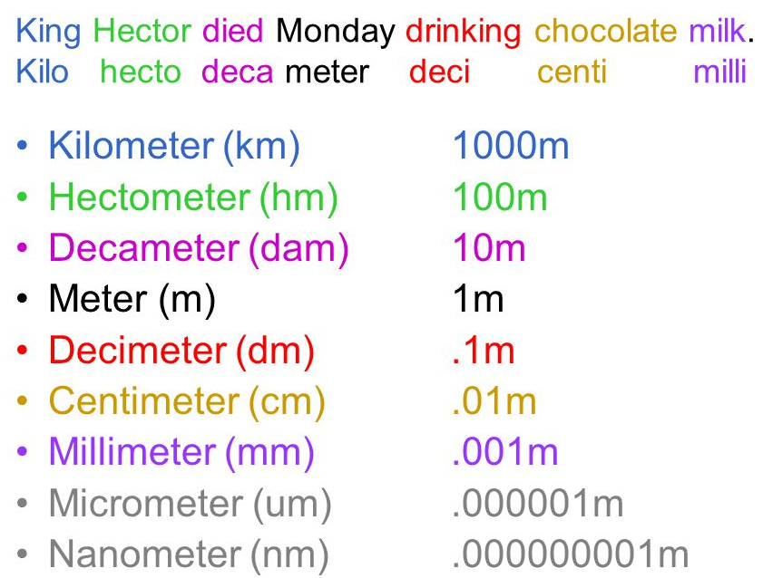
Mr. Miller calls this,
“Level the playing field.”

Using the “Powers of 10,” students should be able to find that 350 ml is .35L by dividing 350 ÷ 10³ = .350.

EXAMPLE

Arrange the following measurements in order from smallest to largest.
3 liters 32,000 milliliters 2.1 liters
STEP 4:
I could also chop off the zeroes for both the dividend and divisor. 32,000 ÷ 1000 = 32

SOLVE
I could set up my work as 32,000 ÷ 1000 and do the traditional algorithm. I could set it up and solve as a “Power of 10,” 32,000 ÷ 10³ = 32, and move the decimal 3 places to the left.

UNDERSTANDING
32,000 is a whole number, so it has a decimal point after the last zero. There are 1000 mL in one liter, so I know that I need to divide 32,000 by 1000.

Remember that when we compare and order numbers we want to stack them, but in the above problem we must first turn 32,000 mL to liters so that we can truly compare.

LITERS
03.0
32.0
02.1
It is important to “Level the playing field.”

Once stacked, it’s easy to see 32L is largest and then obviously 2.1L is smaller than 3L.
In order from smallest to largest: 2.1L, 3L, 32L

BASE TEN

DECIMALS IN WORD (WRITTEN) FORM

Eureka Math: Mod. 1 L. 5
MATH CCSS: 5.NBT.A.3
MATH CCSS: 5.NBT.A.3.A

Standard: Students need to be able to read, write, and compare decimals to thousandths.

TO “AND” OR NOT TO “AND”
Sometimes kids will add the word “and” when saying a number like One thousand three hundred and seventy two, but when saying and writing numbers we want to reserve the word “and” to denote a decimal point. If we use “and” incorrectly, we run the risk of being inaccurate. That number looks like this: 1,300.72
But without the word hundredths following it just sounds wrong.

Let’s say we are writing a check for rent using the above number. Written correctly in word form it would look like this: One thousand three hundred seventy-two and no cents (meaning nothing after the decimal point).

Students need to be able to read and write numbers up to three place values behind the decimal point.

Two-Step Process

1) Say the entire number behind the decimal point.
For instance:
.007 can be said as seven
.092 can be said as ninety-two
.248 can be said as two hundred forty-eight

2) Say the place value of the last digit. In the examples above they all end in the thousandths column on a place value chart.
So the number said correctly is:
.007 is said as seven thousandths
.092 is said as ninety-two thousandths
.248 is said as two hundred forty-eight
thousandths

DECIMALS IN EXPANDED FORM

We learned that expanded form for 347 was 300 + 40 + 7, and maybe we learned it as 3 • 100 + 4 • 10 + 7 • 1 = 347. Both are examples of expanded form. This lesson is no different.

Students will be able to use fractions or decimals to express the decimal place value units.

Hundred Thousands | Ten Thousands | Thousands | Hundreds | Tens | Ones | • | Tenths | Hundredths | Thousandths
100,000 | 10,000 | 1,000 | 100 | 10 | 1 | • | .1 | .01 | .001
100,000 | 10,000 | 1,000 | 100 | 10 | 1 | • | 1  10 | 1  100 | 1  1000
 |  |  |  |  |  | •
 |  |  |  |  |  | •

EXAMPLE

Write an expression that represents the number 2,478.602

In fraction form: (2 • 1000) + (4 • 100) + (7 • 10) + (8 • 1) + (6 • 1/10) + (2 • 1/1000)

In decimal form: (2 • 1000) + (4 • 100) + (7 • 10) + (8 • 1) + (6 • .1) + (2 • .001)

BASE TEN

COMPARE DECIMALS TO THOUSANDTHS

Eureka Math: Mod. 1 L. 6
MATH CCSS: 5.NBT.A.3.B

Standard: Students will compare and possibly order two decimals to thousandths
using <, =, or > symbols to record their comparisons.

Anytime we are comparing two numbers, we should do three things:
1) We should stack them by preserving place value with the decimal point

2) We should fill in any gaps with zero

3) Then compare each digit from left to right

The symbols we use for greater than or less than look like this: < and >, so which is which? Use the hint: “The alligator always goes for the greater meal.”

EXAMPLE

or

Use <, >, or = to compare the following. 16.45 and 16.454
1) Stack them: 2) Fill gaps in with zeroes 3) Compare left to right

16.45 16.450 1 6 . 4 5 0
16.454 16.454 1 6 . 4 5 4

The last digits circled are different, so 16.45 < 16.454

Use <, >, or = to compare the following. 419.10 and 419.099

Some students who don’t complete the steps may say that .10 is less than .099, so its super important to take the time in a real comparison by following the steps above.
1) Stack them: 2) Fill gaps in with zeroes 3) Compare left to right

419.10 419.10 4 1 9 . 1 0 0
419.099 419.099 4 1 9 . 0 9 9

The digits in the tenths place are circled because the difference in numbers is there, and obviously there is a difference between 1 and 0, so 419.10 > 419.099

BASE TEN

ROUNDING: WHOLE AND DECIMALS

Eureka Math: Mod. 1 L. 7-8
MATH CCSS: 5.NBT.A.4

Standard: Students should be able to use place value to round whole numbers and decimals to any place

Rounding is one of those essential basic skills that enhance number sense and mathematical reasoning. Rounding helps a student arrive at a friendly number, so it is easier to estimate probable outcomes, and rounding helps us understand larger more complex numbers better.
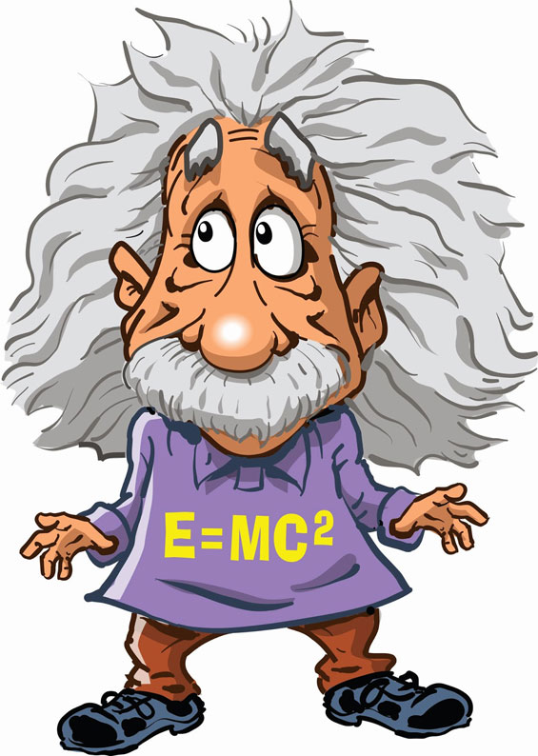
In creating your “Einstein Estimate” you just want to change numbers to easy friendly numbers for yourself. For instance: 278,642 ≈ 300,000 for me, because it is super easy, but some of you might change it to 280,000 or 270,000 based on other numbers being estimated, like 7 and 9.

With decimals, we often round long extended decimals to hundredths, because that mirrors our understanding of money. For instance: 3.26893245 would be rounded to 3.27, or if I’m doing an Einstein Estimate I’ll round it to a simple 3.

The Procedures for Rounding:
1) Underline the digit you are asked to round too

2) Circle the digit on the right and draw an arrow over to the
underlined digit, and ask yourself, “Does the circled digit,
remember 5 is the magic number, change the underlined
digit?”

3) The underlined digit will either stay the same or move up
by one, and if the circled digit is ineffective in changing
the underlined digit, then cross it out.

EXAMPLE

Round 27.36 to the nearest tenth.  2 7 . 3 6  2 7 . 4 | Round 816.243 to the nearest hundredth.  8 1 6 . 2 4 3  8 1 6 . 2 4 | Round 724.398 to the nearest hundredth.  7 2 4 . 3 9 8  7 2 4 . 4 0

BASE TEN

ADDING and SUBTRACTING
MULTI-DIGIT DECIMALS

Eureka Math: Mod. 1 L. 9-10
MATH CCSS: 5.NBT.B.7

Standard: Students will be able to add and subtract decimals to hundredths using models, drawings, properties of operations, and/or the relationship between addition and subtraction. Students will also be able to write a written explanation of reasoning.

The procedure for adding multi-digit (many numbered) decimals is to line up the decimal points. This means you need to stack your addends or subtrahends vertically, and the decimal points have to be directly on top of each other.

In class I ask:
“What is the
procedure
for the adding
and subtracting
of decimals?”

And you all reply:
“Line up the decimals. Chop.”
while moving your paw up
and down grizzly-style.
Kinesthetically, this helps
you memorize the procedure.

EXAMPLE

42.1 + 1.235 216.5 – 0.732
Adding with zeroes is no problem, but subtracting is a whole different issue
because of borrowing and regrouping.

42.100 216.500
+ 01.235 - 000.732
43.335 215.768

Look at these examples without the zeroes and the decimals lined up.

0.32167 + 21,712.4 12.24 – 11.6429453
0.32167 12.24
+ 21712.4 - 11.6429453
00000.32167 12.2400000
+ 21712.40000 - 11.6429453
21712.72167 0.5970547
Notice that I dropped the comma, that’s so I
don’t get confused with the decimal point.

BASE TEN

Eureka Math: Mod. 1 L. 11 & 12
MATH CCSS: 5.NBT.B.5 & 7

MULTIPLYING MULTI-DIGIT DECIMALS

Standard: Fluently multiply multi-digit whole numbers using the standard algorithm, and multiply decimals to the hundredths using concrete models or drawings and strategies. Be able to explain and reason your methodology.

The procedure for multiplying multi-digit decimals is to apply the number of spaces behind the decimal point in each factor (the problem) to the number of spaces in the product (the answer) coming in from the right.
In class I will ask you:
“What is the procedure
for the multiplication
of decimals?”

And you all will reply kinesthetically:
“The number of spaces in the
problem equal the number of
spaces in the answer.”

Mr. Miller’s Method:

1 . 2 1

× 0 . 0 4 3

3 6 3

+ 4 8 4 0

. 0 5 2 0 3

An explanation from the
OUT

Khan Academy on the
5
SPACES
MATHEMATICAL REASONING:
• 100
1.21 121
• 1000
× 0.043 × 43
363
+ 4840
÷ 100 ÷ 1000
.05203 5203
IN

BASE TEN

When we are working with decimals, it is
imperative that we understand the con-
cept of place value. That is one reason
why we often refer to money when
speaking with decimals. Imagine a dollar
broken up into tenths (0.1, or dimes) or hundredths (0.01 or pennies), but we’d never break up a dollar into thousandths (0.001) or ten thousandths (0.0001). That would be the same as if we cut each penny into ten equal pieces (thousandths) or a hundred equal pieces (ten thousandths).
Here
Homer
shows the
procedural
movement
for
multiplying
decimals.

Eureka Math: Mod. 1 L. 12
MATH CCSS: 5.NBT.B.7

CREATING A FRIENDLY NUMBER

Standard: Students should be able to add, subtract, multiply, and divide decimals to hundredths, and one way to double check their work is to change these seemingly difficult numbers to more friendly numbers and follow the operation.

Students should be able to take any number and change it to a more friendly number and compute the operation. This will help us estimate an answer, which becomes increasingly more helpful as we work through the operations of adding decimals, subtracting, multiplying, and dividing decimals.

The “key” to the estimate is looking at numbers in an easy way.

When estimating an operation, ( +, −, ×, or ÷ ), we are basically changing large difficult numbers into easy “friendly” numbers to compute quickly an estimate. Mr. Miller calls this the “Einstein Estimate.”

24.489 ÷ 4.16 =
Don’t over think an easy solution to the problem.

This looks like a lot of work at first, but if I round first then it seemingly got a lot easier:

EXAMPLES

24 ÷ 4 = 6
Remember the gas station sign telling us how much gas is:

Some people will see
regular unleaded gas
at $1.73, but its really
closer to $1.74. Is
$1.74 friendly? Not
really. $1.80 is more
friendly while $2 is
the friendliest, but $1.73 9/10 is a ridiculous number to try and use.

Your estimate should take no longer than 15 seconds EVER. The above problem should have just taken a few seconds. The real answer is 5.886, which is pretty close to 6.

LOOKING AT IT ANOTHER WAY
What if 24.489 ÷ 5.42, now 5 doesn’t really go into 24 easily or quickly. In other words the number 5 is not a factor for the product 24. Here are some ideas to consider:

1) I could still change the 5.42 to a 4, because 4 is a factor of 24 and my quotient would be 6.
NOTICE HOW I BREAK
A LOT OF ROUNDING
RULES TO ESTIMATE
HERE QUICKLY

2) I could change my divisor from 5.42 to a 6, because 6 is a factor of 24. That would make a quotient of 4

3) Lastly, I could change the dividend, 24.489 to 25, because I know 5 is a factor of 25, so the quotient would be 5.
6.08 • 18.4 ≈ 6 • 18
≈ 6 • 20
Which is friendlier? 18 or 20? Well I know 6 • 9 is 54, so doubled would be 108. 6 • 10 is 60; doubled is 120.

The quotient to 24.489 ÷ 5.42 = 4.518. All of my estimates are reasonably close to the actual quotient.

BASE TEN

DIVIDING DECIMALS IN THE DIVIDEND

Eureka Math: Mod. 1 L. 13-16
MATH CCSS: 5.NBT.B.6 & 7

Standard: Find whole number quotients of whole numbers with four-digit dividends and two-digit divisors using the properties of operations. Students should be able to illustrate and explain the calculation by using equations, arrays, and/or area models. Students also need to be able to divide decimals to hundredths.

A solo decimal point in the dividend requires a student to put the decimal point directly on top of the house; of course, ensuring that place value is maintained throughout the division algorithm.

EXAMPLES

This is
the whole procedure.

375.15 ÷ 15 2,898.736 ÷ 23
. .

15 375.15 23 2898.73
E.E..
25.01 126.032
20

20 400
15 375.15 23 2898.736
- 30 - 23
75 59
- 75 - 46
E.E..
150

20 3000
0 15 138
- 15 - 138
0 0 73
- 69
THOUSANDTHS

HUNDREDTHS

TENTHS

DECIMAL PT.

ONES

TENS

HUNDREDS

THOUSANDS

1 2 6 . 0 3 2

23 2 8 9 8 . 7 3 6
46
- 46
0
- - - - - - - - - - - - - - - -
- - - - - - - - - - - - - - - -
- - - - - - - - - - - - - - - -
- - - - - - - - - - - - - - - -
- - - - - - - - - - - - - - - -
- - - - - - - - - - - - - - - -
- - - - - - - - - - - - - - - -
This is how well you should have a division problem lined up.

BASE TEN

DIVISION USING
PLACE VALUE UNDERSTANDING

Eureka Math: Mod. 1 L. 14
MATH CCSS: 5.NBT.B.7

Standard: Students will be able to not only use the algorithm in division but relate the strategy to a written method and explain their reasoning.

Students should be able to use a place value chart to explain the division process using discs and place value to explain their reasoning in division.

EXAMPLES

Starting this process is a little confusing, but the more you do it the easier it will get.

8.736 ÷ 3

•
Ones | Tenths | Hundredths | Thousandths
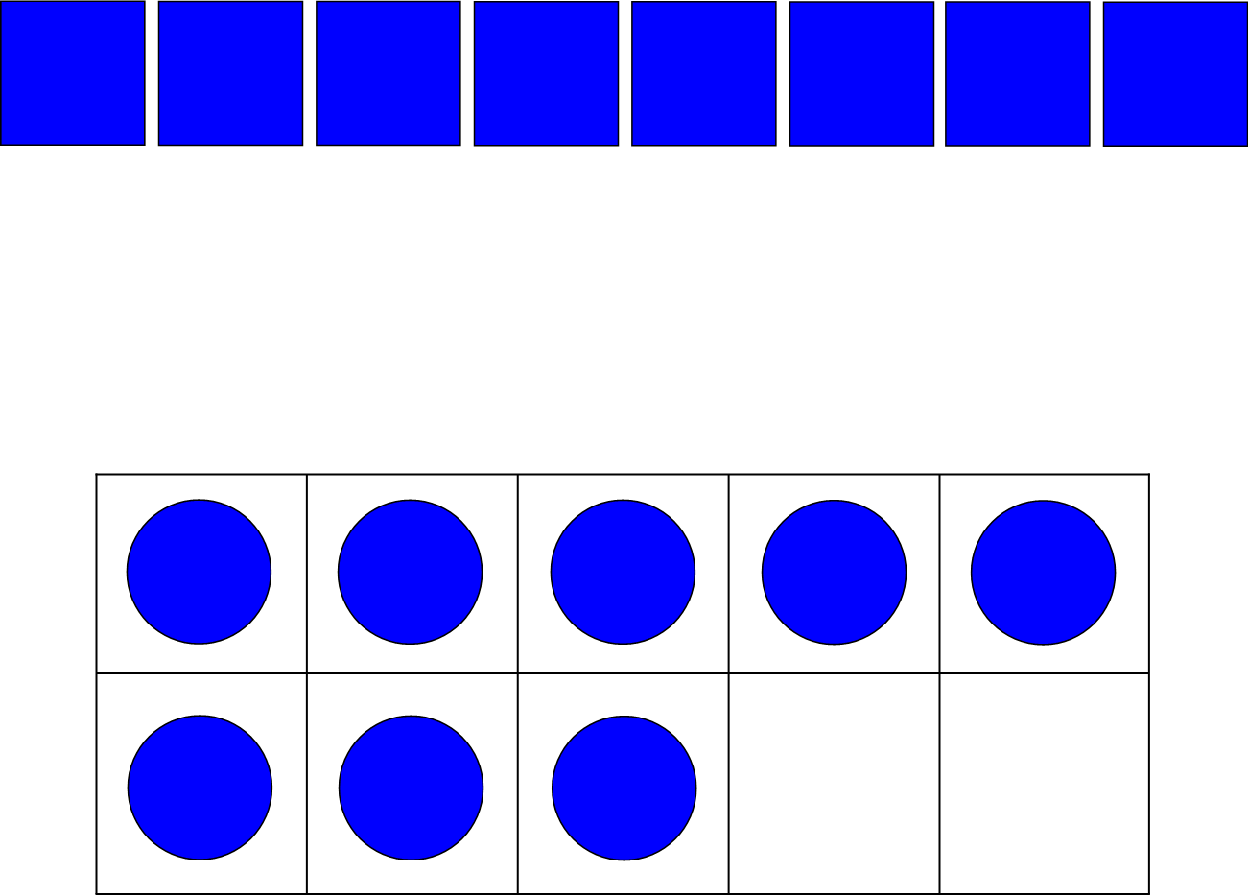 | 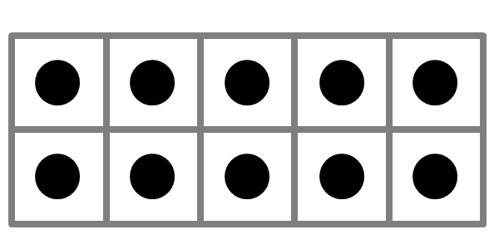  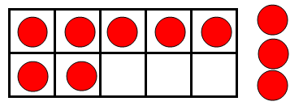 | 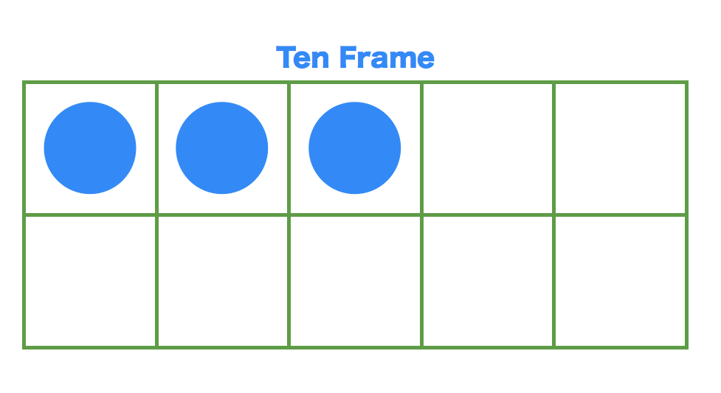
Step 5
I have nothing to carry over to the next column, so I scratch out a disc in the hundredths and make an even group. I do the same with thousandths.

Step 4
I now have 27 discs in the tenths column. Well 27 ÷ 3 = 9. Literally I scratch out a disc and place it in the row below.

Step 3
The goal is to now to begin with the 8 discs in the ones column and divide them evenly among the three rows below.

Step 2
Based on the value of the digit in the dividend, I am going to place a number of discs in that box.

Step 1
Based on the divisor, 3, I will create three rows below the placement of my discs.

Explanation: I first placed 8 discs
in the ones column, 7 in the tenths,
3 in the hundredths and 6 in the thousandths. Because the divisor is 3 I
created three rows below. I found that I could make a group of 2 in the ones with 2 left over, which meant I transferred a total of 20 discs into the tenths column (10 discs for each one). Next, I could make a group of 9 in the tenths column with nothing left over, a group of I in the hundredths and lastly a group of 2 in the thousandths. My answer was 2.912.

BASE TEN

Eureka Math: Mod. 1 L.
MATH CCSS: 5.NBT.B.7

DIVIDING DECIMALS WITH A DECIMAL
IN THE DIVISOR AND DIVIDEND

Standard: The lesson below is really more of a 6th Grade example, meaning that the dividend and divisor are a little larger than expected for 5th Graders, but the quotient is also a decimal. For 5th Graders the quotient will always be a whole number.

The decimal point in the divisor dictates how much the decimal point moves to the right in the dividend. In other words, whatever number of spaces you move the decimal point in the divisor, you must also move the decimal point in the dividend… even if there isn’t a decimal point in the dividend.

When I ask students, “What is the procedure for the division of decimals?” They reply, “The number of spaces in the divisor equal the number of spaces in the dividend… to the right.”

EXAMPLES

999.6 ÷ 58.8 9.4806 ÷ 6.73
. .

5 8.8 9 9 9.6 . 6.7 3 9.4 8 .0 6
This is the whole procedure.

1 7 . 1 .4 0 8

5 8.8 9 9 9.6 . 6.7 3 9.4 8 .0 6 0
- 5 8 8 - 6 7 3
4 1 1 6 2 7 5 0
- 4 1 1 6 - 2 6 9 2
0 5 8 6 0
EXPLANATION
In this example you are multiplying the divisor, 6.73 by 100, and the dividend by 100 to maintain balance. So 6.73 becomes 673 and 1.4806 becomes 148.06.

- 5 3 8 4
4 7 6
EXPLANATION
You are basically multiplying the divisor, 58.8 by 10, which equals 588. If you multiply the divisor by 10, then you must also multiply the dividend by 10 to maintain balance. So 999.6 becomes 9996.

BASE TEN

MATH CCSS: 5.NF.B.3
MATH CCSS: 6.RPA.3.C

Eureka Math: Mod. 1 L.
MATH CCSS: 4.NF.C.6 & 7

5TH GRADE CONVERTING FRACTIONS TO DECIMALS AND DECIMALS TO FRACTIONS

6TH GRADE CONVERTING TO PERCENTS

Standard: In 4th Grade students learned equivalency of fractions and that they could convert.54 to 54/100. In 5th Grade students learn that fractions are division of the numerator by the denominator, thus leading to a decimal equivalent. True conversion of fractions to decimals to percent is a 6th Grade standard.

Convert Decimals to Fractions and Percent

- Converting a decimal to a fraction is as simple as identifying its place value. Take the decimal point away and draw in a line for the fraction bar underneath. That number is your numerator, and the denominator is its place value.

.7 = 7 .32 = 32 0.375 = 375
10 100 1000
- Converting a decimal to a percent is as easy as removing the decimal point and adding a percentage sign. We are literally taking, .64, and multiplying it by 100 to get 64%.

Converting Percent to Decimals and Fractions

- To convert a percent to a decimal, first remove the percentage sign and add a decimal point from the right side coming in two places as in 42% is .42 or 630% is 6.30.

- With converting a percent to a fraction go one step more by then following the steps in converting a decimal to a fraction as in this example:
This mathematical practice is the piece that is more of a 6th Grade standard.

SIMPLIFYING

64% = .64 = 64 ÷ 2 = 32 ÷ 2 = 16
100 ÷ 2 50 ÷ 2 25

Converting Fractions to Decimals and Percent

- To convert a fraction to a decimal, simply divide by locking down the divisor and moving the numerator into the dividend position. Add a decimal point and three zeroes.

- And in converting a fraction to a percent, do step one above, round it to the nearest hundredth, then multiply that decimal by 100. That will be your percent.

BASE TEN

5th GRADE SKILLS I SHOULD BE ABLE TO DO
IN NUMBERS AND OPERATIONS IN BASE TEN

1) Recreate a place value chart accurately.
2) Understand that a digit in the hundreds column is 10 times larger than a
digit in the tens column and 1/10 as great as a digit in the thousands
column.
3) Understand the value of a digit given its place value
4) Understand that every number has a decimal point whether you see it or
not.
5) Understand the “Powers of 10” and be able to multiply and divide using
that understanding
6) Be familiar with and use the metric system in measuring length and
volume, and convert units within the system
7) Be able to write out numbers in written form
8) Be able to write out numbers in expanded form
9) Be able to compare two numbers by stacking them and using the
symbols: < and >
10) Round any whole number or decimal to another place value
11) Follow the procedures for rounding a number
12) Use rounding to create “friendly” numbers for quick estimation
13) Know and understand the procedure for adding and subtracting
decimals
14) Be able to add and subtract decimals fluently
15) Know and understand the procedure for the multiplication of decimals
16) Be able to multiply decimals fluently
17) Know and understand the procedure for the division of decimals in the
dividend
18) Know and understand the procedure for the division of decimals in the
divisor
19) Be able to divide decimals in the dividend and divisor fluently.
20) Be able to convert and understand fraction to decimal equivalency
21) Be able to convert and understand decimal to fraction equivalency

