STATISTICS AND PROBABILITY
STUDY GUIDE, Page 1

- Xiomara is writing a report about rainbows and needs to gather data from her classmates.

Which is a statistical question Xiomara could ask?

- What are the colors of the rainbow?
- When was the first rainbow seen?
- Is there really a pot of gold at the end of the rainbow?
- How many rainbows have you seen this month?
- Where in the sky was the rainbow located?
- How long did the rainbow last?
- Which color is most visible in the rainbow?

- A survey was taken of how many magazines are purchased annually. The results are in this set of data.

1, 2, 3, 4, 4, 5, 5, 5, 5, 6, 6, 7, 12, 36, 104

Which is the most representative measure of center for this data?

A) Median C) Mean
B) Range D) Interquartile Range

STATISTICS AND PROBABILITY STUDY GUIDE, Page 2

- Terrence is interested in finding the average quiz grade for all the 10-point quizzes he took in Mr. Miller’s History class.
9, 10, 7, 5, 8, 7, 6

Part A: Which measure would be most accurate?
A) Median C) Mean
B) Range D) Mode
E) Interquartile Range E) Outlier

Part B: Identify the mean, mode, median, and range

Part C: Is there any outlier? Why or why not?
____________________________________________________________________________________________________________________________________________________________________________________________

- What is the interquartile range of the following data?

4, 4, 10, 11, 15, 7, 14, 12, 6

STATISTICS AND PROBABILITY STUDY GUIDE, Page 3

- A statistical question anticipates variability in the data related to it. Determine whether each question can be classified as a statistical question. Select yes of no for each question.

QUESTION | YES | NO
1. How many hours a week do people exercise?
2. How many hours are there in a day?
3. How often do you have dessert in a week?

6. Consider this data set.

10 | 11 | 12 | 11
9 | 8 | 9 | 9
11 | 9 | 8 | 7

Click above the number line to create a dot plot for the data set.

6
7
14
8
9
10
11
12
13
7

STATISTICS AND PROBABILITY STUDY GUIDE, Page 4

7. Consider this data set.

10 | 7 | 12 | 11
13 | 8 | 14 | 9
4 | 9 | 8 | 7

Click within the graph area to create a histogram for the data set.
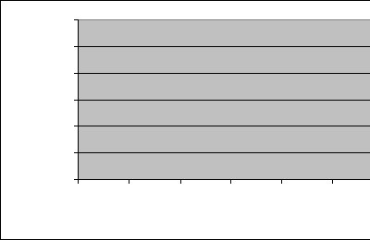
6
5
TIMES APPEARING
4
3
2
1
0
12-15
8-11
4-7
NUMBERS IN SET

- What is the mean price of an individual avocado over the past several months given the data below?

$1.69, $2.99, .99¢, $1.99, $2.69

STATISTICS AND PROBABILITY STUDY GUIDE, Page 5

- Frank surveyed his neighbors to see how much money they spent on gasoline each week. The results are in the dot plot shown.
.
. . .
. . . . . . .
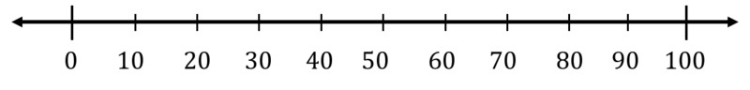

Enter the total number of people Frank surveyed.

- The following dot plot shows the daily temperature in San Pedro, California in January. Each dot represents a different day.

How many days had a temperature of at least 12°C?

STATISTICS AND PROBABILITY STUDY GUIDE, Page 6

- Elizabeth surveyed her friends to see how many minutes they studied for their math test last evening. The results are in this list.

10, 20, 5, 30, 12, 15, 25, 10

Enter the mode and median of the data.

- The Principal at Leland, is interested in finding the average height of her culminating 6th graders. Create a histogram below with the given data in inches.

INCHES | QUANTITY | INCHES | QUANTITY | INCHES | QUANTITY
47” | 1 | 48” | 0 | 49” | 2
50” | 0 | 51” | 2 | 52” | 4
55” | 3 | 56” | 4 | 57” | 6
58” | 2 | 59” | 0 | 60” | 1

__________________________
_________________________
- - - - - - - - - - - - - - -- - - - - - - - - - - - - - - -
- - - - - - - - - - - - - - - - - - - - - - - - - - - - - - -
- - - - - - -- - - - - - - - - -- - - - - - - - - - - - - - -
- - - - - - - - - - - - - - - - - - - - -- - - - - - - - - - -
- - - - - - - - - - - - - - - - - - - - - - - - - - - - - - -
- - - - - - - - - - - - - - - - - - - - - - - - - - - - - - -
- - - - - - - - - - - - - - - - - - - - - - - - - - - - - - -
46 47 48 49 50 51 52 53 54 55 56 57 58 59 60
_________________________

STATISTICS AND PROBABILITY STUDY GUIDE, Page 7

- Identify the measures of center, and explain why these terms are the measures of center.

A) interquartile range D) median
B) mean absolute deviation E) range
C) mode F) mean

____________________________________________________________________________________________________________________________________________________________________________

- Consider the shape of this data:
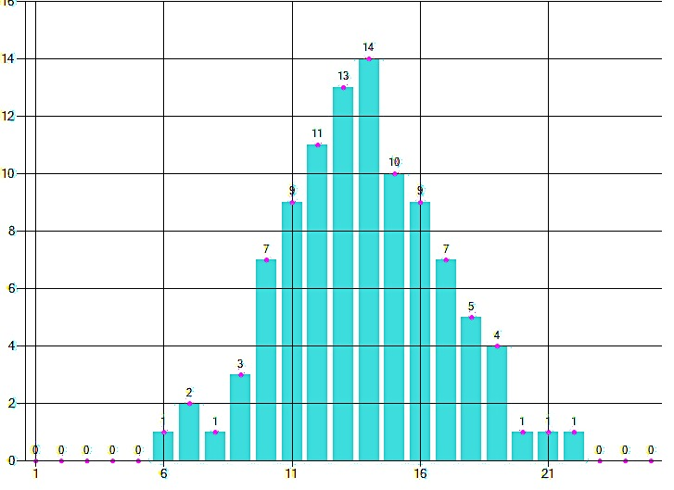
Based on the
shape of the
data, which is
the most
representative
measure of
variation?

A) median D) mean
B) mean absolute deviation E) mode
C) interquartile range F) range

STATISTICS AND PROBABILITY STUDY GUIDE, Page 8

16. Erick has been studying every night for his upcoming math test over the past 10 nights. The time spent on studying are listed below:

10, 15, 20, 15, 35, 5, 25, 20, 30, 25

Enter the mean of this data. ______

Enter the mode of this data. ______

Identify the first quartile. ______

Identify the third quartile. ______

- Consider the data set below:

10 | 5 | 12 | 11
13 | 5 | 14 | 7
7 | 10 | 6 | 3

Enter the median of the data set. ______
STATISTICS AND PROBABILITY STUDY GUIDE, Page 9

17. Nicholas loves to eat Dodger dogs, and after tallying all the Dodger dogs he ate while attending games last year these are the results of dogs eaten per game:

6, 2, 5, 3, 7, 3, 4, 2, 5

Enter the mean absolute deviation. ______

- Consider this data:

10, 11, 12, 9, 15, 9, 7, 4, 8

Determine if each statement is true. Select true or false for each statement.

STATEMENT |  | TRUE | FALSE
Changing the 4 to a 15 will increase the median
Changing the 4 to a 15 will decrease the range
Changing the 4 to a 15 will not change the mean
 | STATISTICS AND PROBABILITY STUDY GUIDE, Page 10

18. Consider the data set below:

10 | 11 | 12 | 11
5 | 8 | 9 | 13
13 | 14 | 7 | 9

Draw a box plot to display the data set.

19. What information can be ascertained from the box plot display? Use the box plot above to help explain your answer

___________________________________________________________________________________________________________________________________________________________________________________________________________________________________________
_______________________________________________
STATISTICS AND PROBABILITY STUDY GUIDE, PAGE 11

20. Consider the histograms below:
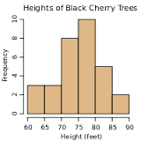
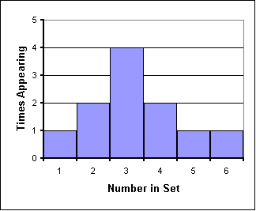

Which histogram is more accurate? Explain why.

____________________________________________________________________________________________________________________________________________________________________________________________

In which histogram am I more likely to find an exact mean given the data set? Explain why.

____________________________________________________________________________________________________________________________________________________________________________________________

STATISTICS AND PROBABILITY STUDY GUIDE, PAGE 12

- Consider the data on Michael Jordan’s and Kobe Bryant’s points per game average between the ages of 21 and 32:

Michael Jordan Kobe Bryant

29 | 23 | 37 | 33
35 | 0 | 34 | 27
32 | 30 | 33 | 30

23 | 29 | 30 | 27
27 | 27 | 36 | 24
32 | 28 | 27 | 25

Find the mean, median, mode, range, outliers if any, interquartile range, and mean absolute deviation

Based on the data set which player was the better scorer and give your analysis for that judgment.

____________________________________________________________________________________________________________________________________________________________________________________________

